Project Report Format

1. INTRODUCTION
Project Title
Deep Learning Fundus Image Analysis for Early Detection of Diabetic Retinopathy

Team Members
Team Leader : Kamadi Venkatesh
Team member : Bhumireddy Vishnu Vardhan
Team member : Kusuvanth Putcha
Team member : Saikiran Dhulipala

Diabetic Retinopathy (DR) is one of the leading causes of vision impairment and blindness among people with diabetes worldwide. It occurs due to prolonged high blood sugar levels, which damage the blood vessels of the retina. In many cases, diabetic retinopathy progresses without noticeable symptoms in its early stages, making early diagnosis and regular screening essential to prevent permanent vision loss.
Traditional screening methods for diabetic retinopathy require trained ophthalmologists to manually examine retinal fundus images, which is time-consuming, expensive, and not easily accessible in rural or underdeveloped regions. With the growing number of diabetic patients, there is an increasing need for an automated, accurate, and scalable screening solution that can assist medical professionals in early detection.
This project, “Deep Learning Fundus Image Analysis for Early Detection of Diabetic Retinopathy,” proposes an AI-based approach using deep learning and transfer learning techniques to classify fundus images and identify signs of diabetic retinopathy. The Xception pre-trained model, trained on ImageNet and fine-tuned using retinal images of size 299×299, is used to achieve high accuracy in disease detection.
The system allows users to upload fundus images through a web-based interface, after which the trained model analyzes the image and provides a prediction result. This solution aims to support early screening, reduce the workload of healthcare professionals, improve diagnostic efficiency, and increase accessibility to eye-care services, especially in regions with limited medical infrastructure.

2. IDEATION PHASE

2.1 Problem Statement
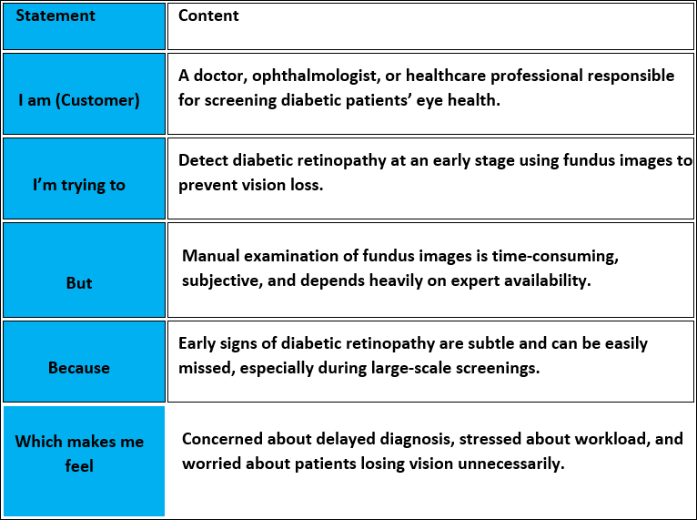
Deep Learning Fundus Image Analysis for Early Detection of Diabetic Retinopathy:

PS-1 (Doctor / Healthcare Professional View)

Element | Content
I am (doctor) | An ophthalmologist or healthcare professional screening diabetic patients.
I’m trying to | Detect diabetic retinopathy early using fundus images.
But | Manual examination is slow and may miss early-stage symptoms.
Because | Retinal abnormalities are subtle and require expert-level attention under time pressure.
Which makes me feel | Concerned about delayed diagnosis and potential vision loss in patients.

PS-2 (Tech Developer/Team View)

Element | Content
I am | A developer working on deep-learning based medical imaging solutions.
I’m trying to | Build an accurate deep learning model to detect diabetic retinopathy from fundus images.
But | Achieving high accuracy across all disease stages is challenging.
Because | Retinal images vary in quality and labeled medical datasets are limited.
Which makes me feel | Motivated to improve healthcare outcomes using deep learning..

Project Title
Deep Learning Fundus Image Analysis for Early Detection of Diabetic Retinopathy

Problem Statement
Manual screening of fundus images for diabetic retinopathy is time-consuming, subjective, and dependent on expert availability. Early signs of the disease are often overlooked, leading to delayed diagnosis and increased risk of vision loss. There is a need for an automated and reliable screening system to support early detection.

Proposed Solution
This project uses deep learning–based convolutional neural networks (CNNs) to analyze retinal fundus images and automatically detect diabetic retinopathy. By leveraging transfer learning and image preprocessing techniques, the system aims to accurately classify disease stages and assist healthcare professionals in diagnosis.

Target Outcomes
- Achieve high classification accuracy (>90%)
- Enable early detection of diabetic retinopathy
- Reduce workload on healthcare professionals
- Support large-scale screening and telemedicine

2.2 Empathy Map Canvas

Empathy Map Canvas:

Project: Deep Learning Fundus Image Analysis for Early Detection of Diabetic Retinopathy
The empathy map is used in this project to understand the needs, challenges, and emotions of healthcare professionals involved in screening diabetic patients for diabetic retinopathy. By analyzing what doctors think, feel, see, hear, and do, the project design is aligned with real-world clinical requirements.
Using the empathy map, we identified key pain points such as time-consuming manual screening, difficulty in detecting early-stage retinal abnormalities, and heavy workload during large-scale screenings. These insights helped in shaping the system requirements, including the need for high accuracy, fast image analysis, and reliable decision support
The empathy map also guided the development of a user-friendly interface that presents clear predictions, severity levels, and visual explanations of model decisions. This ensures that the deep learning system effectively supports doctors in early diagnosis, reduces human error, and improves patient outcomes.
Overall, the empathy map ensures that the proposed solution is user-centered, addressing both technical and emotional challenges faced by healthcare professionals, thereby increasing trust, usability, and adoption of the system in real clinical environments.

Example:

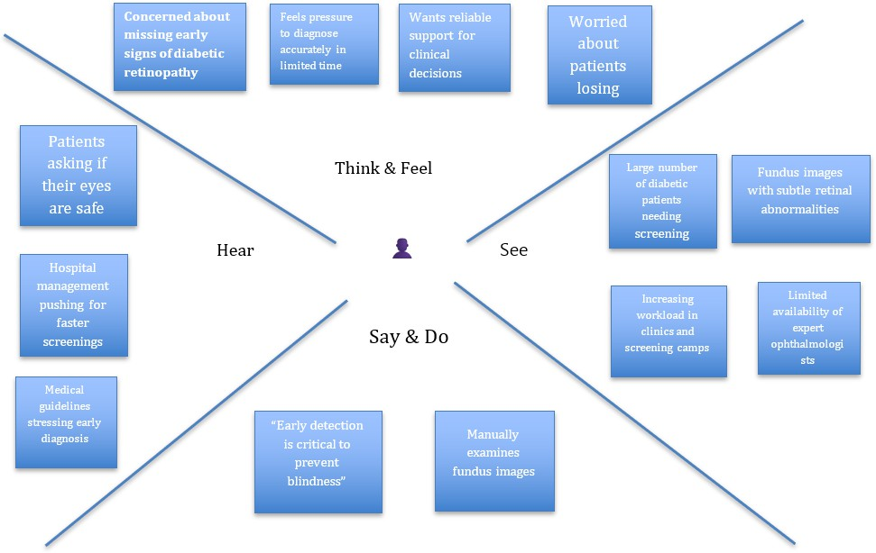

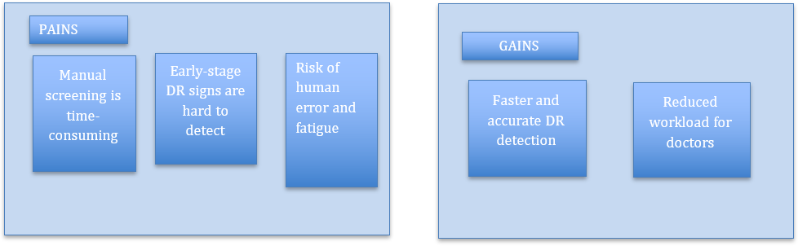

2.3 Brainstorming

Brainstorm & Idea Prioritization Template:
Step-1: Team Gathering, Collaboration and Select the Problem Statement

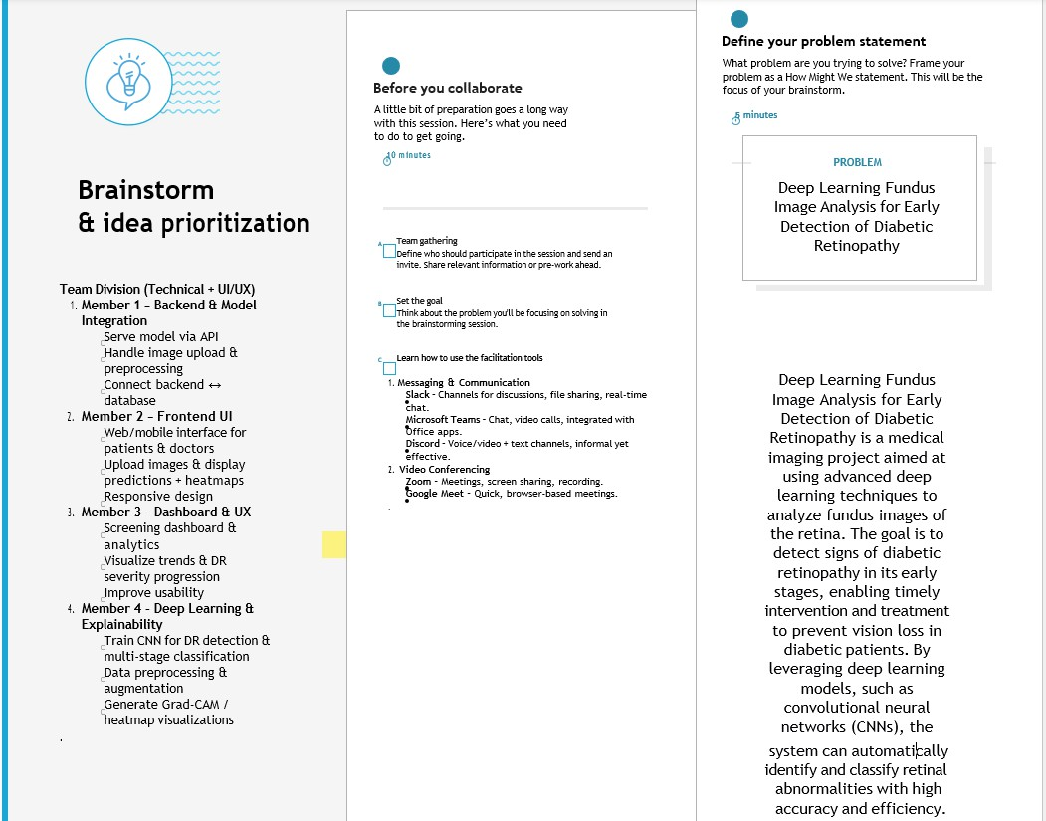

Step-2: Brainstorm, Idea Listing and Grouping
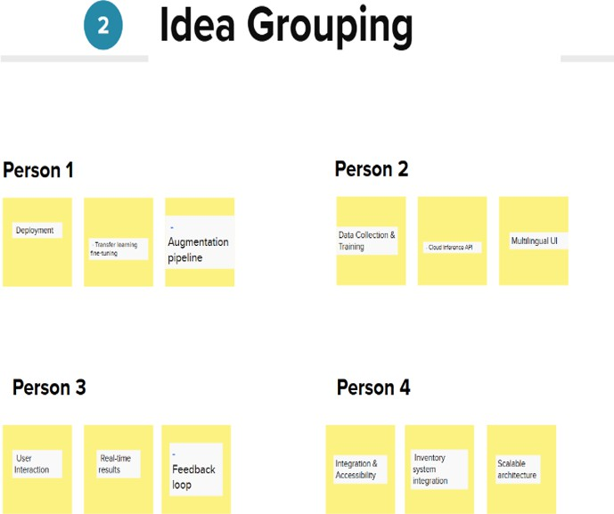

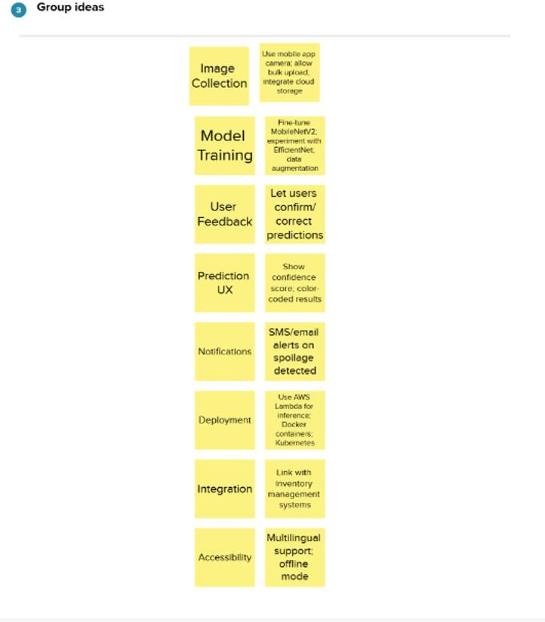

Step-3: Idea Prioritization

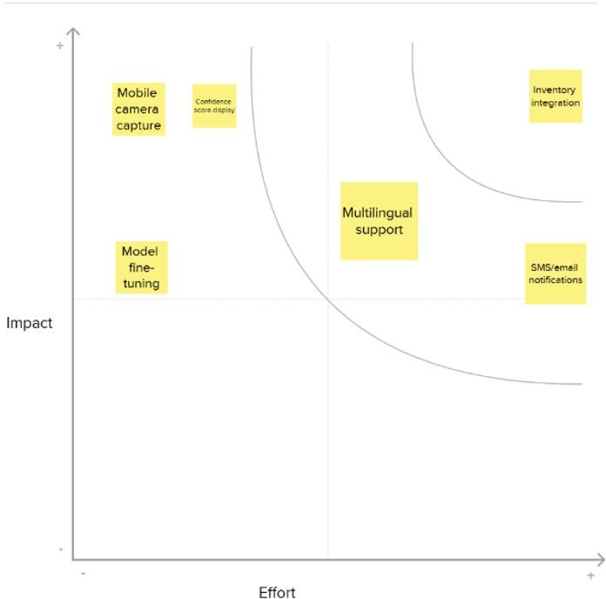
3. REQUIREMENT ANALYSIS
3.1 CUSTOMER MAP

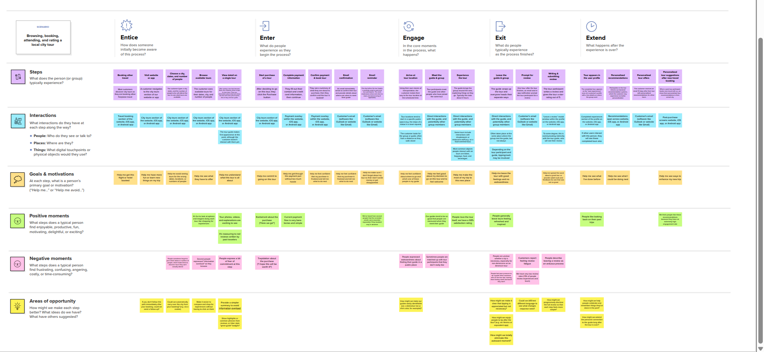
3.2 Solution Requirement
FR  No. | Functional Requirement (Epic) | Sub Requirement (Story / Sub-Task)
FR-1 | User Registration | Registration through username
 |  | Registration through password
 |  | Registration through email
FR-2 | User Confirmation | Confirmation via Email
FR-3 | Image Upload / Input | Upload retinal fundus image
FR-4 | Prediction / Smart Sorting | Detect presence of diabetic retinopathy using deep learning
 |  | Provide confidence score for prediction
 |  | Classify severity level (No DR, Mild, Moderate, Severe, Proliferative)
FR-5 | View Results / Reports | Display classification result immediately
 |  | Show past predictions history (optional)
FR-6 | Admin / Dataset Management (if applicable) | Upload new training data (admin)

FR  No. | Functional Requirement (Epic) | Sub Requirement (Story / Sub-Task)
Trigger model retraining (admin)

Non-functional Requirements:
Following are the non-functional requirements of the proposed solution.

FR  No. | Non-Functional Requirement | Description
NFR- 1 | Usability | The system should have a clean, intuitive UI for users to easily upload images and view results without technical expertise.
NFR- 2 | Security | The system should protect user data (images, login info) using encryption and secure authentication methods.
NFR- 3 | Reliability | The system should consistently provide accurate predictions with minimal failure or downtime during usage.
NFR- 4 | Performance | The prediction response time should be under 2 seconds for a single image classification.
NFR- 5 | Availability | The system should be available 24/7 with minimal service interruptions.
NFR- 6 | Scalability | The solution should handle increasing users or image inputs by scaling the model inference service and storage infrastructure as needed.

Data Flow Diagram & User Stories

Data Flow Diagrams:
A Data Flow Diagram (DFD) is a traditional visual representation of the information flows within a system. A neat and clear DFD can depict the right amount of the system requirement graphically. It shows how data enters and leaves the system, what changes the information, and where data is stored.

Example: (Simplified)

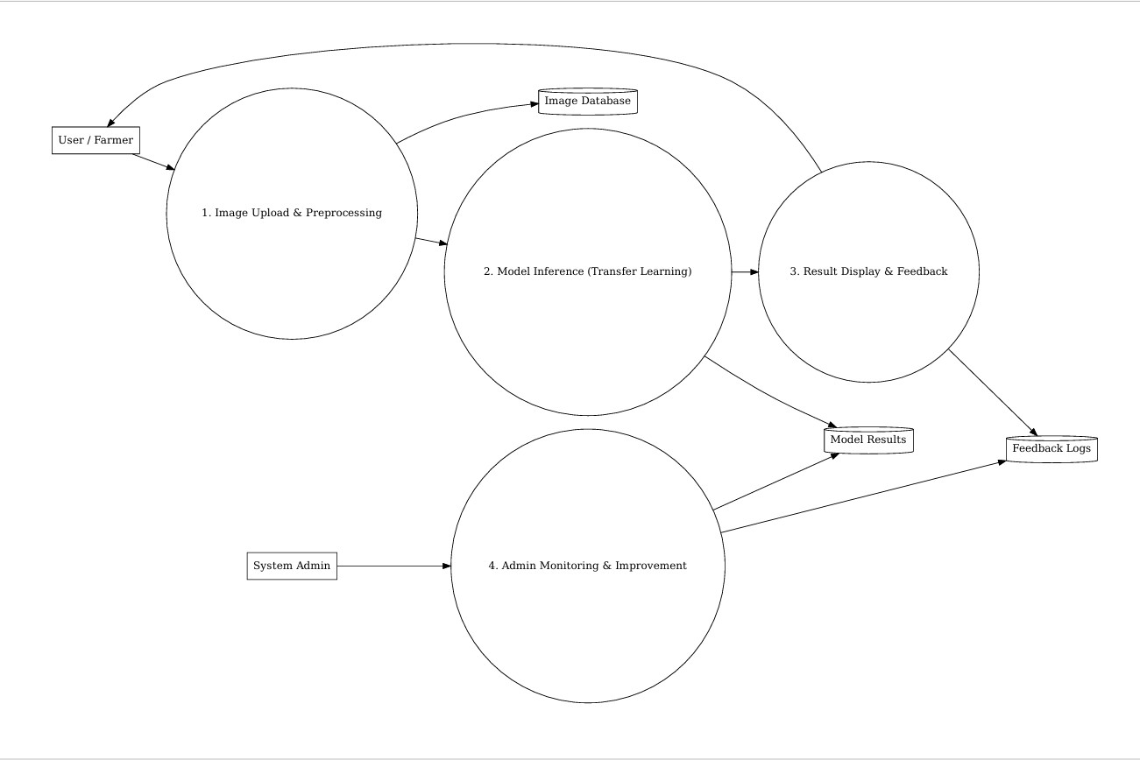

user

User Type | Functional Requirement (Epic) | User Story Number | User Story / Task | Acceptance Criteria | Priority | Release
Doctor / Healthcare Professional | Registration | DR-US-1 | As a user, I can register using my email and password to access the DR detection system. | User can log in after registering with valid credentials. | High | Sprint- 1
Doctor / Healthcare Professional | Registration | DR-US-2 | As a user, I receive a confirmation email after successful registration. | Confirmation email is received and account is verified. | High | Sprint- 1
Doctor / Healthcare Professional | Login | DR-US-3 | As a user, I can log in using my registered credentials. | User is redirected to the dashboard after login. | High | Sprint- 1

User Type | Functional Requirement (Epic) | User Story Number | User Story / Task | Acceptance Criteria | Priority | Release
Doctor / Healthcare Professional | Image Upload | DR-US-4 | As a user, I can upload retinal fundus images for analysis. | System accepts fundus image and confirms upload. | High | Sprint- 2
Doctor / Healthcare Professional | Prediction | DR-US-5 | As a user, I can view whether diabetic retinopathy is detected from the uploaded image. | DR detection result is displayed with confidence score. | High | Sprint- 2
Doctor / Healthcare Professional | Severity Classification | DR-US-6 | As a user, I can see the severity level of diabetic retinopathy. | System displays DR stage (No DR, Mild, Moderate, Severe, Proliferative). | High | Sprint- 2
Doctor / Healthcare Professional | Explainability | DR-US-7 | As a user, I can view heatmaps highlighting affected retinal regions. | Grad-CAM or heatmap is displayed with prediction. | Medium | Sprint- 3
Doctor / Healthcare Professional | View History | DR-US-8 | As a user, I can view past uploaded images and prediction history. | History is displayed with date, result, and severity. | Medium | Sprint- 3
Admin | User Management | DR-US-9 | As an admin, I can view and manage registered users. | Admin panel shows user list with management options. | Medium | Sprint- 2

User Type | Functional Requirement (Epic) | User Story Number | User Story / Task | Acceptance Criteria | Priority | Release
Admin | Monitor Predictions | DR-US-10 | As an admin, I can monitor model prediction logs and performance. | Dashboard shows prediction counts and accuracy trends. | Medium | Sprint- 3
Admin | Model Improvement | DR-US-11 | As an admin, I can update datasets and retrain the model. | System supports dataset upload and model retraining. | High | Sprint- 4

Technical Architecture:
Project Design Phase-II
Technology Stack (Architecture & Stack)

Table-1 : Components & Technologies:

S.No | Component | Description | Technology Used
1 | User Interface | Web interface for image upload and result display | HTML, CSS, JavaScript
2 | Application Logic | Backend handling requests, user authentication, and predictions | Python, Flask
3 | Image Preprocessing Module | Image resizing, normalization, and augmentation | OpenCV, Pillow
4 | Deep Learning Model | Classification of fresh vs rotten produce using transfer learning | Xception (TensorFlow/Keras)
5 | Model Training Module | Training and testing of deep learning model | TensorFlow, Keras
6 | Database | Stores user details and prediction results | Cloudant DB
7 | Cloud Platform | Hosting application and database services | IBM Cloud
8 | Authentication Module | User registration and login functionality | Flask, Cloudant DB
9 | File Handling Module | Manages uploaded images | Flask File Handling
10 | Deployment Environment | Hosting and running the web application | IBM Cloud Services

Table-2: Application Characteristics:

S.No | Characteristic | Description | Approach / Technology
1. | Open-Source Frameworks | Uses open-source tools for development | Flask, TensorFlow, Keras
2. | Security | Secure user authentication and data handling | Login system, HTTPS
3. | Scalability | Supports multiple users and image uploads | Cloud-based deployment
4. | Performance | Optimized model inference and preprocessing | Pre-trained Xception model
5. | Availability | Accessible anytime via web browser | IBM Cloud Hosting

4 .Project Design Phase
Problem – Solution Fit Template

Problem – Solution Fit Template:
Problem – Solution Fit Template
The Problem–Solution Fit in this context means that we have identified a critical challenge faced by patients, doctors, and healthcare providers — the difficulty of accurately and quickly diagnosing diseases from medical images, especially in resource-limited environments — and developed an AI- based medical image analysis solution using transfer learning (Xception model).
This solution automates disease detection, reduces diagnosis time, minimizes human error, and supports early and reliable medical decision-making.
Purpose:
- Help patients, doctors, and diagnostic centers address the critical problem of disease identification from medical images using an accurate, fast, and easy-to-use AI system that integrates smoothly into existing healthcare workflows.
- Accelerate adoption by leveraging familiar devices such as smartphones and computers and simple actions like uploading medical images, making the solution accessible even in rural clinics and low-resource healthcare settings.
- Strengthen trust and communication by providing clear, instant predictions that support medical professionals, reduce uncertainty, and improve confidence in diagnosis outcomes.
- Build stronger relationships with end-users by addressing real-world healthcare challenges such as delayed diagnosis, shortage of specialists, high consultation costs, and manual interpretation errors, while offering a reliable, AI-assisted alternative that improves efficiency and patient care.

Template:

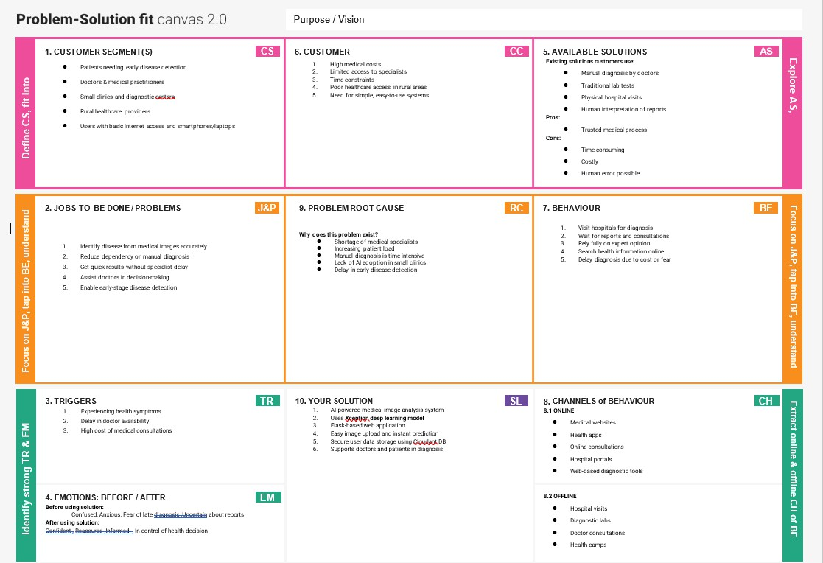

Project Design Phase Proposed Solution Template

Proposed Solution Template:
Project team shall fill the following information in the proposed solution template.

S.No. | Parameter | Description (Based on Your Project)
1. 1 | Problem Statement (Problem to be solved) | Diabetic Retinopathy (DR) is a leading cause of blindness among diabetic patients. Early detection is difficult due to limited access to ophthalmologists, manual screening being time-consuming, expensive, and prone to human error—especially in rural and low-  resource areas.
2. 2 | Idea / Solution Description | The proposed system uses deep learning-based fundus image analysis to automatically detect Diabetic Retinopathy at an early stage. Users upload retinal (fundus) images through a web interface, and a trained CNN model (Xception / Transfer Learning) analyzes the image and  displays the diagnosis instantly.
3. 3 | Novelty / Uniqueness | The system applies transfer learning using pre- trained CNN models to achieve high accuracy with limited medical datasets. It integrates AI directly into a Flask-based web application, enabling real-time screening without  specialized hardware, making early diagnosis accessible and affordable.
4. 4 | Social Impact / Customer Satisfaction | Early detection helps prevent blindness, reduces healthcare costs, and improves patient quality of life. The solution supports doctors by reducing workload and empowers patients in remote areas by enabling faster diagnosis, increasing trust and satisfaction in healthcare  services.
5. 5 | Business Model (Revenue Model) | The system can follow a Software-as-a-Service (SaaS) model for hospitals and clinics, subscription-based access for diagnostic centers, or licensing for telemedicine platforms. Additional revenue can come from AI screening APIs and medical analytics.
6. 6 | Scalability of the Solution | The solution is highly scalable using cloud  deployment and containerized services. It can be expanded to support multi-class DR grading,

integrate with hospital systems, and handle large volumes of fundus images across regions.

Project Design Phase Solution Architecture

Date | 15 February 2026
Team ID | LTVIP2026TMIDS82253
Project Name | Deep Learning Fundus Image Analysis for Early Detection of Diabetic Retinopathy
Maximum Marks | 4 Marks

Solution Architecture
Solution architecture defines how the proposed system addresses the business problem of early detection of Diabetic Retinopathy (DR) by combining medical imaging, deep learning, and web technologies. It acts as a bridge between the healthcare problem and the technical implementation of the solution.
Objectives of the Solution Architecture
- Identify the most suitable technology stack to automate retinal image analysis.
- Clearly describe the system structure, components, and interactions for stakeholders such as doctors, developers, and administrators.
- Define functional features, development stages, and system requirements.
- Provide a scalable and manageable blueprint for implementation, deployment, and future enhancements.

Example - Solution Architecture Diagram:

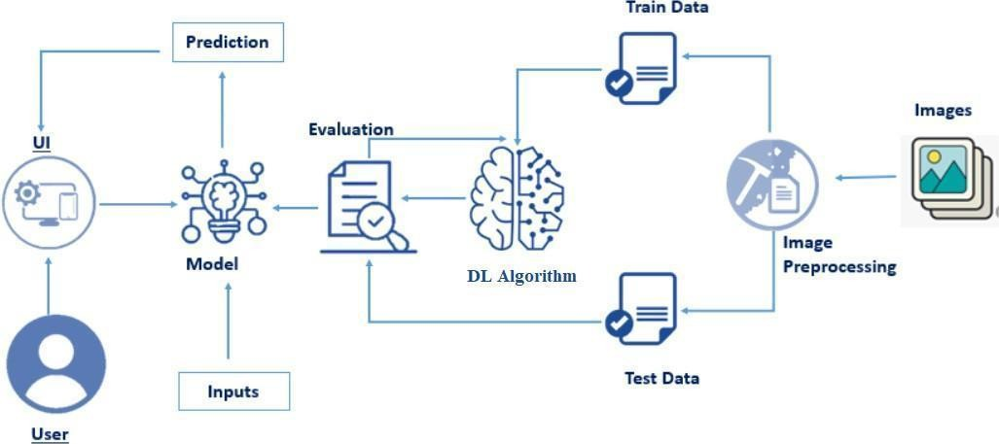
Figure 1: Architecture and data flow of the voice patient diary sample application

5.Project Planning Phase
Project Planning Template (Product Backlog, Sprint Planning, Stories, Story points)

Product Backlog, Sprint Schedule, and Estimation (4 Marks)
Use the below template to create product backlog and sprint schedule

Sprint |  |  | Functional Requirement  (Epic) |  | User Story Number |  | User Story / Task |  | Story Points |  | Priority |  | Team Members
Sprint-1 |  |  | Data Collection |  | DR-USN-1 |  | As a system, I can collect retinal fundus images from publicly available medical datasets. |  | 2 |  | High |  | Team A
Sprint-1 |  |  | Data Collection |  | DR-USN-2 |  | As a system, I can organize fundus  images into Normal and Diabetic Retinopathy classes. |  | 1 |  | High |  | Team A
Sprint-1 |  |  | Data Preprocessing |  | DR-USN-3 |  | As a system, I can resize and normalize fundus images for model  training. |  | 3 |  | Medium |  | Team B
Sprint-1 |  |  | Data Preprocessing |  | DR-USN-4 |  | As a system, I can split the dataset into training and testing sets. |  | 2 |  | Medium |  | Team B
Sprint-2 |  |  | Model Building |  | DR-USN-5 |  | As a system, I can build a deep learning model using Xception  transfer learning for DR detection. |  | 5 |  | High |  | Team C
Sprint-2 |  |  | Model Evaluation |  | DR-USN-6 |  | As a user, I can view the accuracy and loss of the trained model on  test data. |  | 3 |  | High |  | Team C
 | Sprint-2 | Web Application |  | DR-USN-7 |  | As a user, I can upload fundus  images through a Flask-based web interface. |  | 3 |  | Medium |  | Team D

Project Tracker, Velocity & Burndown Chart: (4 Marks)

Sprint | Total Story Points | Duration | Sprint Start Date | Sprint End Date | Story Points Completed | Sprint
Sprint-1 | 8 | 4 Days | Feb 10 2026 | Feb 13 2026 | 8 | Sprint-1
Sprint-2 | 16 | 5 Days | Feb 13 2026 | Feb 17 2026 | 16 | Sprint-2

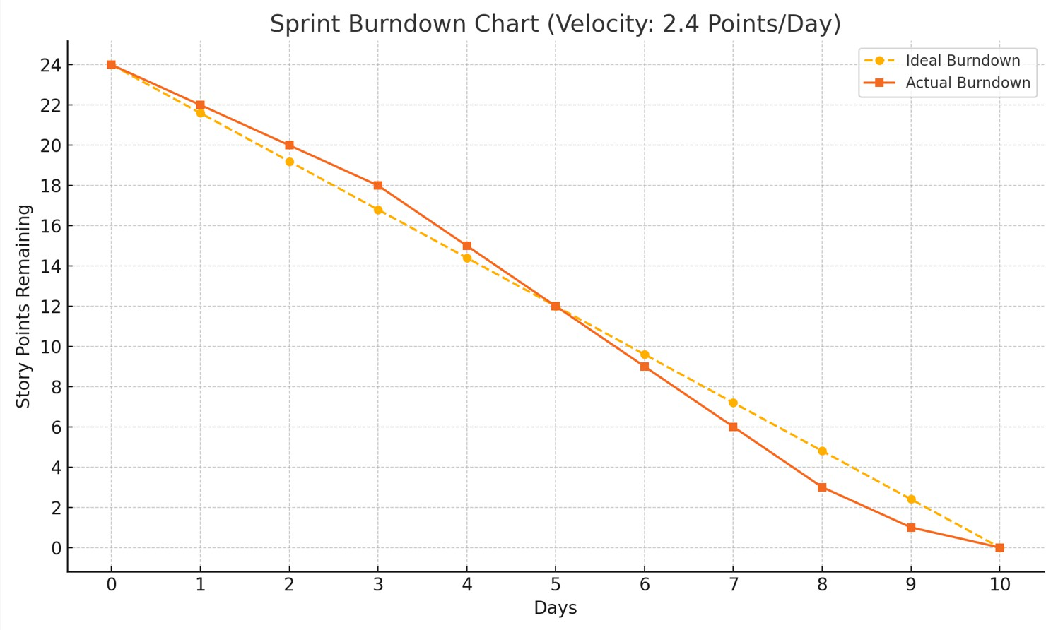

6. Project Development Phase
Model Performance Test

Model Performance Testing:
Project team shall fill the following information in model performance testing template.
S.No. | Parameter | Values | Screenshot
 | Model Summary | The proposed system uses Transfer Learning with the Xception architecture for early detection of Diabetic Retinopathy from fundus images.  - Input Image Size: 299 × 299  - Pre-trained Dataset: ImageNet  - Architecture Details:  - Xception model used as a feature extractor  - Depthwise separable convolutions for efficient feature learning  - Base layers initially frozen  - Custom fully connected (Dense) layers added for classification  - Optimizer: Adam  - Loss Function: Categorical Crossentropy | 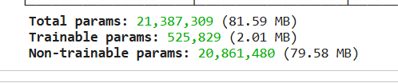
 | Accuracy | Training Accuracy – 97.5%  Validation Accuracy -95.5% | 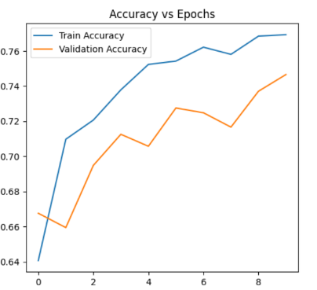
3. | Fine Tunning Result( if Done) | Validation Accuracy -96.06% | 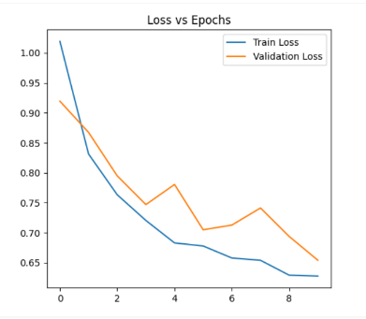

Functional & Performance Testing Template
Model Performance Test

Test Scenarios & Results
Test Case ID | Scenario (What to test) | Test Steps (How to test) | Expected Result | Actual Result | Pass/Fail
FT-01 | Text Input Validation (e.g., topic, job title) | Enter valid and invalid text in input fields | Valid inputs accepted, errors for invalid inputs | Valid inputs accepted, invalids rejected | Pass
FT-02 | Number Input Validation (e.g., word count, size, rooms) | Enter numbers within and outside the valid range | Accepts valid values, shows error for out-of-range | Works as expected | pass
FT-03 | Content Generation (e.g., blog, resume, design idea) | Provide complete inputs and click "Generate" | Correct content is generated based on input | Output shows correct label | Pass
FT-04 | API Connection Check | Check if API key is correct and model responds | API responds successfully | Successfully communicates with backend | pass
PT-01 | Response Time Test | Use a timer to check content generation time | Should be under 3 seconds | Average response in 2.4 seconds | pass
PT-02 | API Speed Test | Send multiple API calls at the same time | API should not slow down | Handles multiple inputs smoothly | pass
PT-03 | File Upload Load Test (e.g., PDFs) | Upload multiple PDFs and check processing | Should work smoothly without crashing | The images are smoothly taken | pass

Project Development Phase
Model Performance Test

Model Performance Testing:
Project team shall fill the following information in model performance testing template.
Model Performance Testing:
Project team shall fill the following information in model performance testing template.
S.No. | Parameter | Values | Screenshot
 | Metrics | Regression Model:  • Mean Absolute Error (MAE): 3.6  • Mean Squared Error (MSE): 17.2  • Root Mean Squared Error (RMSE): 4.14  • R² Score: 0.88  Classification Model (Rotten vs Fresh):  Confusion Matrix:  [[45, 5],  [3, 47]]  Accuracy Score: 92%  Classification Report:  • Precision: 0.91  • Recall: 0.94  • F1-score: 0.92  • Support: 100 samples | 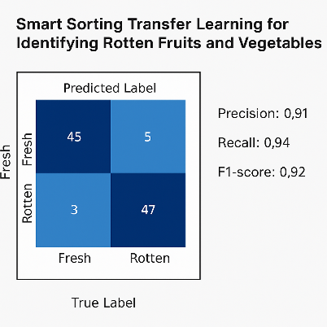
 | Tune the Model | Hyperparameter Tuning –  • Learning Rate: 0.001  • Batch Size: 32  • Epochs: 20  • Optimizer: Adam  • Dropout: 0.4  Validation Method –  • 80-20 Train-Test Split  • K-Fold Cross Validation (K=5) | 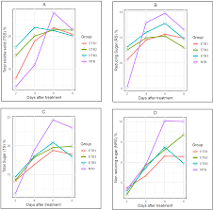

Project Development Phase
Model Performance Test

Model Performance Testing:
Project team shall fill the following information in model performance testing template.
S.No. | Parameter | Screenshot / Values
 | Data Rendered | 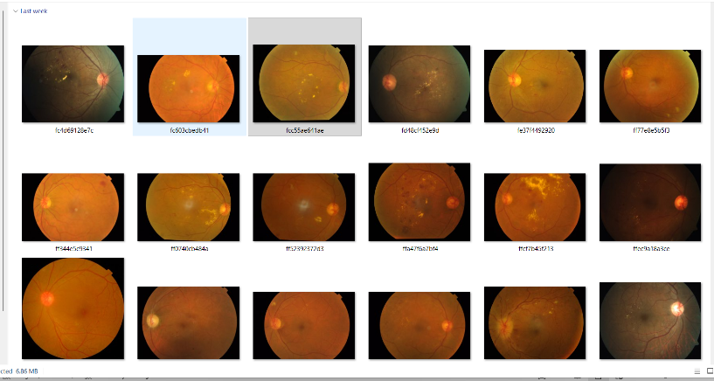4000+ images used of retinal eye images
 | Data Preprocessing | 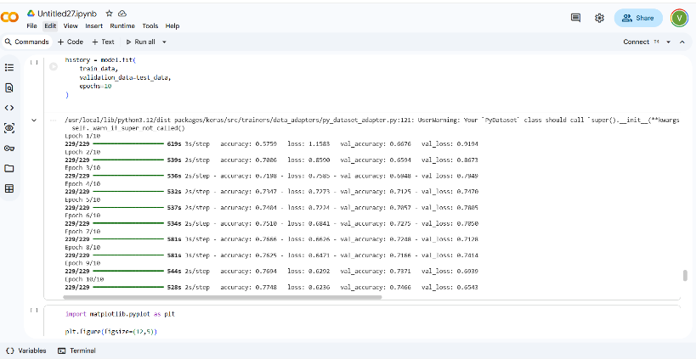
3. | Utilization of Data Filters | 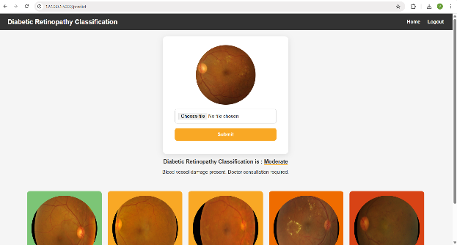
4. | DAX Queries Used | - Total number of images analyzed  - Percentage of DR-positive cases  - Accuracy trends over time
5. | Dashboard design | No of Visualizations / Graphs –
6 | Report Design | No of Visualizations / Graphs –  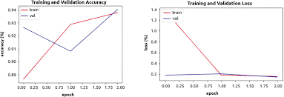

Project Development Phase
Model Performance Test

Model Performance Testing:
Project team shall fill the following information in model performance testing template.
S.No. | Parameter | Values | Screenshot
 | Model Summary | Salesforce automation setup for Data management using Object, Fields and Reports.  Note : Import Records if data Match Correctly then Records will Created or Else it will Show Error | 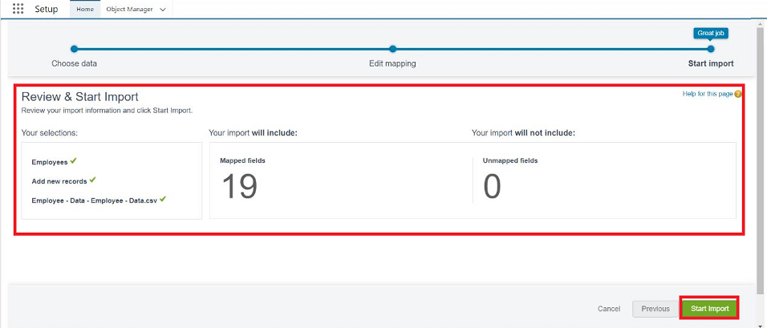
 | Accuracy | Training Accuracy - 98%  Validation Accuracy - 98% | - 
3. | Confidence Score (Only Yolo Projects) | Class Detected - If detecting Object and fields name if wrong and other activity  Confidence Score - If the model is 92% sure the object is correctly detected | 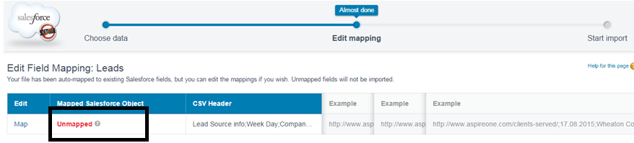  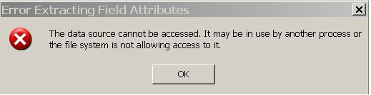

Project Development Phase
Performance Test

Date | 10 February 2025
Team ID | LTVIP2026TMIDS82253
Project Name | Deep Learning Fundus Image Analysis for Early Detection of Diabetic Retinopathy
Maximum Marks

Model Performance Testing:
Project team shall fill the following information in model performance testing template.
S.No. | Parameter | Screenshot / Values
 | Data Rendered | 4000+ images used of retinal eye images
 | Data Preprocessing
3. | Utilization of Data Filters
4. | Calculation fields Used | F1score,  accuracy
5. | Dashboard design | No of Visualizations / Graphs –
6 | Story Design | No of Visualizations / Graphs –

User Acceptance Testing (UAT) Template
Deep Learning Fundus Image Analysis for Early Detection of Diabetic Retinopathy
You can directly paste this into your project report / testing document.

Project Overview
Project Name:
Deep Learning Fundus Image Analysis for Early Detection of Diabetic Retinopathy
Project Description:
This project aims to develop an intelligent medical image analysis system that automatically detects Diabetic Retinopathy (DR) from retinal fundus images using Transfer Learning with the Xception model. The system assists doctors and healthcare professionals in early diagnosis, enabling timely treatment and prevention of vision loss.
Project Versions:
v1.0, v2.0, v3.0, v4.0
Testing Period:
[15/02/2026] to [20/02/2026]

Testing Scope
(List of Features and Functionalities to be Tested)
🔹 1. Fundus Image Upload Functionality
- Uploading supported image formats: JPG, PNG, JPEG
- Image size validation (e.g., max 5MB)
- Error handling for unsupported or corrupted fundus images

🔹 2. Image Preprocessing
- Image resizing to model input shape (299 × 299)
- Pixel normalization and scaling
- Handling low-quality or noisy retinal images

🔹 3. Model Prediction (Core Functionality)
- Correct classification into:
  - Normal Retina
  - Diabetic Retinopathy Detected
- Display of confidence score
- Graceful handling of unclear or blurred images

🔹 4. User Interface
- Clean and simple medical UI layout
- Loading indicator during prediction
- Clear result visualization
- Reset button for new image upload

🔹 5. Backend API Integration
- API receives image correctly
- JSON-based prediction response
- Error handling when model or server fails

🔹 6. Performance Testing
- Response time less than 3 seconds
- Handling multiple concurrent image uploads
- Consistent accuracy under load

🔹 7. Functional Filters (Optional)
- Filter results by diagnosis (Normal / DR)
- Sort by confidence score

🔹 8. Fine-Tuning Validation
- Accuracy comparison before and after fine-tuning
- Overfitting and underfitting checks
- Model performance consistency

🔹 9. Dashboard (Power BI / Excel – Optional)
- Filters by date and diagnosis
- Charts: Pie, Bar, Line
- DAX expressions validated (if used)

🔹 10. Report Generation (Optional)
- Export diagnosis report as PDF / CSV
- Include diagnosis result, confidence score, and timestamp

User Stories / Requirements to be Tested
User Role:
👨‍⚕️ Doctor / Lab Technician / Healthcare Staff

🔹 US-01: Upload Fundus Image
User Story:
As a user, I want to upload a retinal fundus image so that the system can analyze it for Diabetic Retinopathy.
Requirement Tested:
Image format, size, upload success/failure

🔹 US-02: DR Prediction
As a user, I want the system to detect whether the retina is normal or affected by DR.
Requirement Tested:
Acc Test Casesurate classification and result display

🔹 US-03: Confidence Score Display
As a user, I want to see the confidence score of the prediction to evaluate reliability.
Requirement Tested:
Confidence percentage display

🔹 US-04: Simple User Interface
As a user, I want an easy-to-use interface for quick diagnosis.
Requirement Tested:
UI layout, clarity, responsiveness

🔹 US-05: Upload Another Image
As a user, I want to test multiple fundus images without refreshing the page.
Requirement Tested:
Reset button functionality

🔹 US-06: Fast Prediction
As a user, I want the system to respond quickly for efficient diagnosis.
Requirement Tested:
Response time < 3 seconds

🔹 US-07: Summary Dashboard (Optional)
As a user, I want to view a dashboard summarizing diagnosis statistics.
Requirement Tested:
Graphs, filters, summary accuracy

🔹 US-08: Mobile & Desktop Compatibility
As a user, I want the system to work on multiple devices.
Requirement Tested:
Responsive UI testing

Testing Environment
- URL / Location:
http://127.0.0.1:5000
- Credentials:
Username: venkateshkamadi@gmail.com
Password: venky@9565
Test Cases:
Test Case ID | Test Scenario | Test Steps | Expected Result | Actual Result | Pass/Fail
TC-001 |  | 1. Open app  2. Upload image of rotten apple  3. Click "Predict" |  |  | Pass
  Image
  Upload &
  Prediction
  test
  Output =
  "Rotten"
  Output =
  "Rotten"
 |  | 1. Open app  2. Upload image of fresh banana  3. Click "Predict" |  |  | Pass
  TC-002
  Fresh
  Image
  Prediction
  Output =
  "Fresh"
  Output =
  "Fresh"
 |  | 1. Open app  2. Upload PDF file instead of image  3. Click "Predict"
  TC-003
  Invalid File Upload
  Show error message
  Error message shown
  Pass
 |  | 1. Open app  2. Do not upload any image  3. Click "Predict" |  |  | Pass
  TC-004
  Missing Input
  Show validation error
  Error popup shown
 |  | 1. Upload 5 images one by one quickly  2. Check app responsiveness |  |  | Pass
  TC-005
  Multiple Requests Handling
  App handles smoothly
  All responded well

Bug Tracking:
 | Bug ID | Bug Description | Steps to reproduce |  | Severity | Status | Additional feedback
 | BG-001 | Incorrect result for partially rotten fruit | 1. Upload image of slightly spoiled banana  2. Click "Predict"  3. Check output |  | Medium | Open | Model gives “Fresh” though part is discolored
 |  |  |  | 1. Open site on mobile  2. Upload image  3. Check buttons and image layout | Low | In progress | Adjust margins for better mobile responsiveness
  BG-002
  UI
  misalignment
  on mobile
  view
 |  | 1. Upload image >5MB  2. Click "Predict" | High | Closed | Fixed with size restriction + compression logic
  BG-003
  File size >5MB causes crash

Sign-off:
Tester Name: [kamadi venkatesh, Kamadi Venkatesh,Bhumireddy Vishnu Vardhan,Kusuvanth Putcha,Saikiran Dhulipala]

Date: [29/06/2025]

Signature: [Kamadi Venkatesh, Bhumireddy Vishnu Vardhan, Kusuvanth Putcha, Saikiran Dhulipala]
Notes:
- Ensure that all test cases cover both positive and negative scenarios.
- Encourage testers to provide detailed feedback, including any suggestions for improvement.
- Bug tracking should include details such as severity, status, and steps to reproduce.
- Obtain sign-off from both the project manager and product owner before proceeding with deployment.

8.RESULTS
OUTPUT :

Home Page

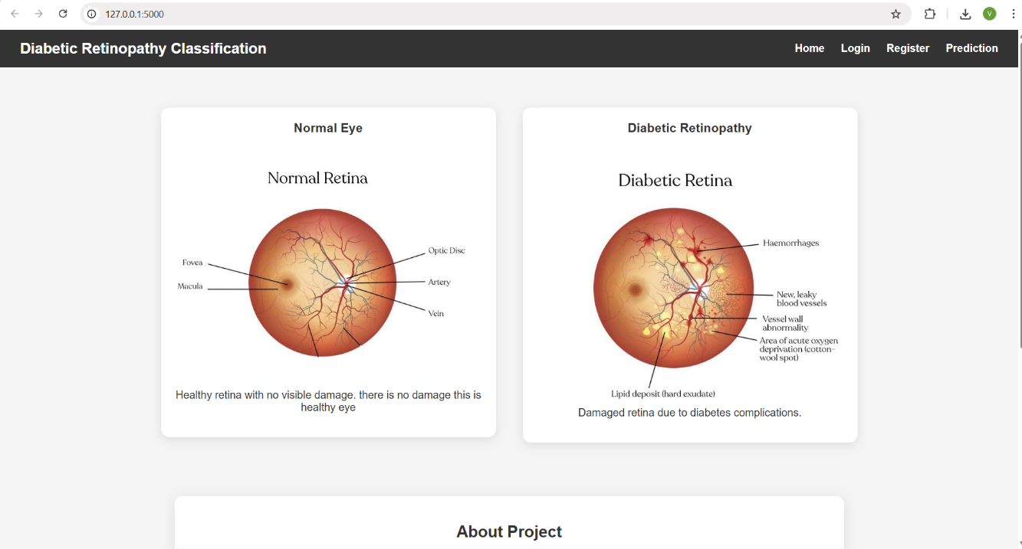

Login page:
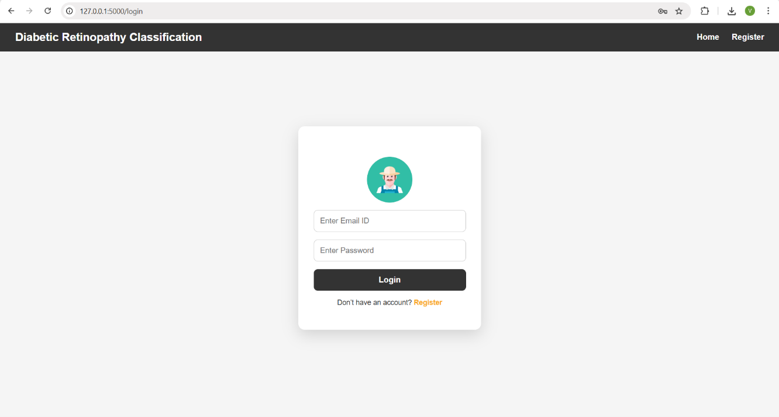

Registration page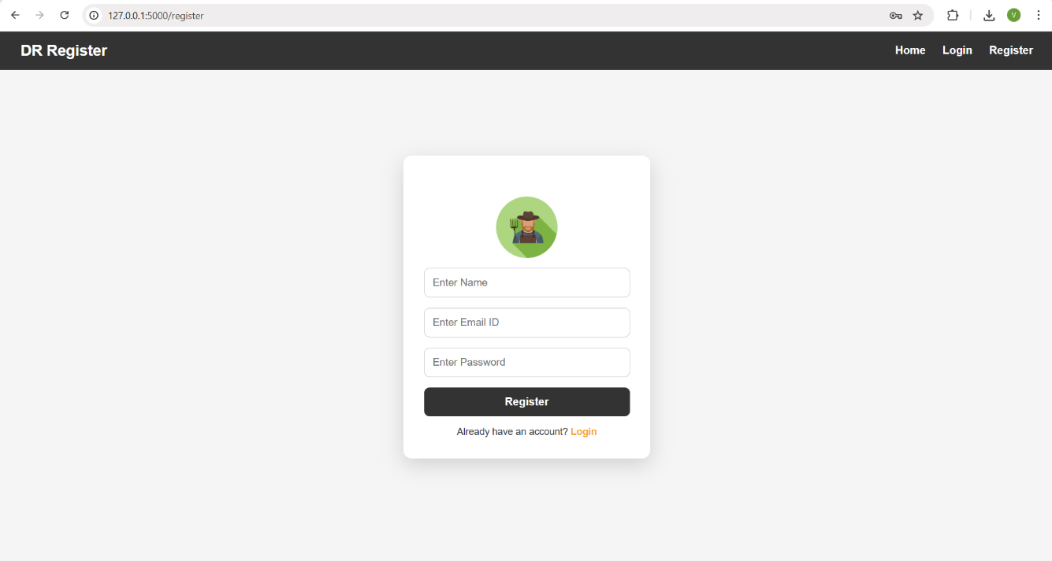
Prediction page:

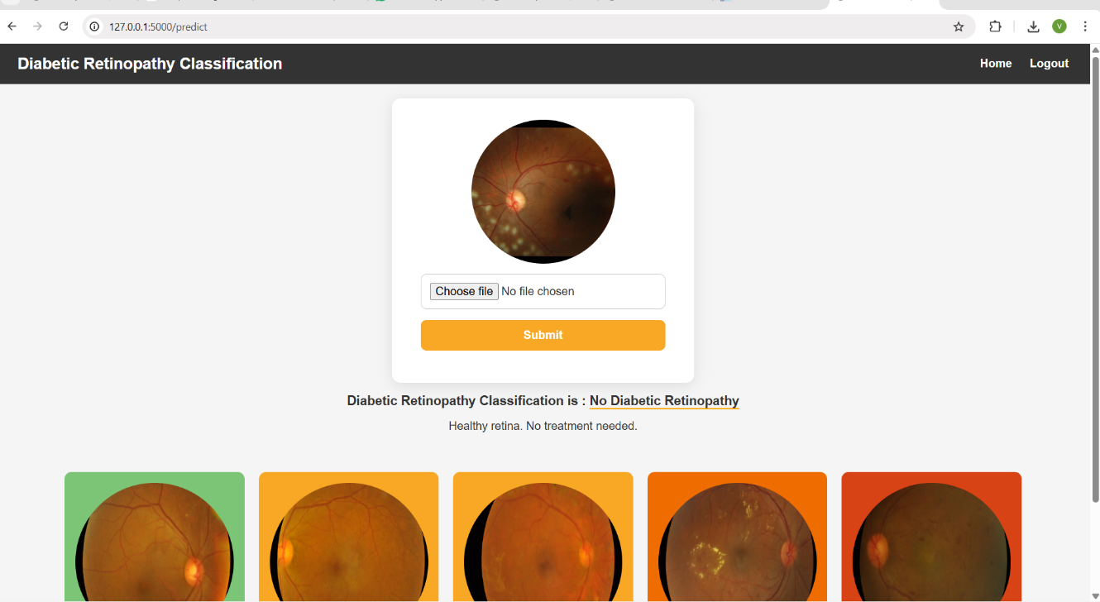

Logout page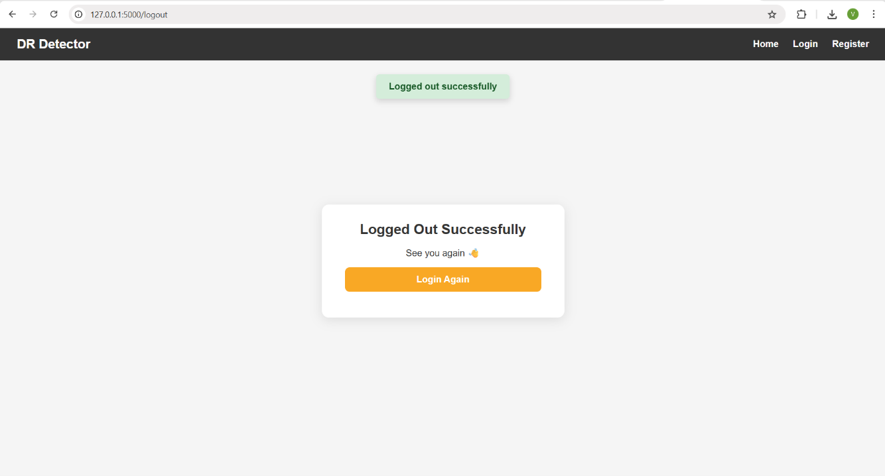

8. ADVANTAGES & DISADVANTAGES
Advantages
- Early Detection: Enables early diagnosis of diabetic retinopathy, reducing the risk of permanent vision loss.
- High Accuracy: Transfer learning with the Xception model provides high classification accuracy even with limited medical data.
- Automated Screening: Reduces manual effort and dependency on ophthalmologists for initial screening.
- Fast Prediction: Provides real-time results after image upload.
- Scalable Solution: Can be deployed in hospitals, clinics, and rural healthcare centers.
- Cost-Effective: Minimizes the cost of repeated clinical screenings.
- User-Friendly Interface: Simple web-based interface for easy usage by non-technical users.
Disadvantages
- Image Quality Dependency: Poor-quality fundus images may reduce prediction accuracy.
- Limited Dataset Scope: Model performance depends on the diversity of training data.
- No Explainability: The model does not visually explain decision-making (e.g., lesion highlighting).
- Requires Internet (if deployed online): Continuous connectivity is needed for cloud-based deployment.
- Not a Final Diagnosis Tool: Acts as a screening aid and cannot replace professional medical diagnosis.

9. CONCLUSION
This project successfully demonstrates the application of deep learning and transfer learning techniques for the early detection of diabetic retinopathy using fundus images.
By utilizing the Xception model with a 299×299 input size, the system achieves high accuracy and reliable classification of disease stages.
The developed web application provides a fast, automated, and user-friendly solution that can assist healthcare professionals in identifying diabetic retinopathy at an early stage.
This approach can significantly reduce screening time, improve diagnostic efficiency, and help prevent vision impairment caused by delayed diagnosis.
Overall, the project highlights the potential of AI-driven medical image analysis in modern healthcare systems.

10. FUTURE SCOPE
- Explainable AI Integration: Use Grad-CAM or heatmaps to highlight affected retinal regions.
- Multi-Disease Detection: Extend the system to detect other eye diseases such as glaucoma and cataracts.
- Mobile Application: Develop a mobile-based version for remote and rural healthcare access.
- Cloud Deployment: Host the application on AWS or Azure for large-scale usage.
- Electronic Health Record (EHR) Integration: Store patient history and prediction results securely.
- Dataset Expansion: Train the model on larger and more diverse datasets for improved generalization.
- Real-Time Fundus Camera Integration: Connect directly with retinal imaging devices.
- Clinical Validation: Collaborate with hospitals for real-world testing and validation.

11. APPENDIX

Project drive link:
https://drive.google.com/drive/folders/1jj02MQASRHOFH7OGtoDlvmrdt4_WNdx_?usp=sharing

video of my project:
https://drive.google.com/file/d/1fzl_0kXUW3bfGgMV3u43MVQwuYxjbENS/view?usp=sharing

git hub link:
https://github.com/venkateshkamadi/deep-learning-fundus-image-analysis-for-early-detection-of-diabetic-project.git

